COOLE NATIONAL SCHOOL
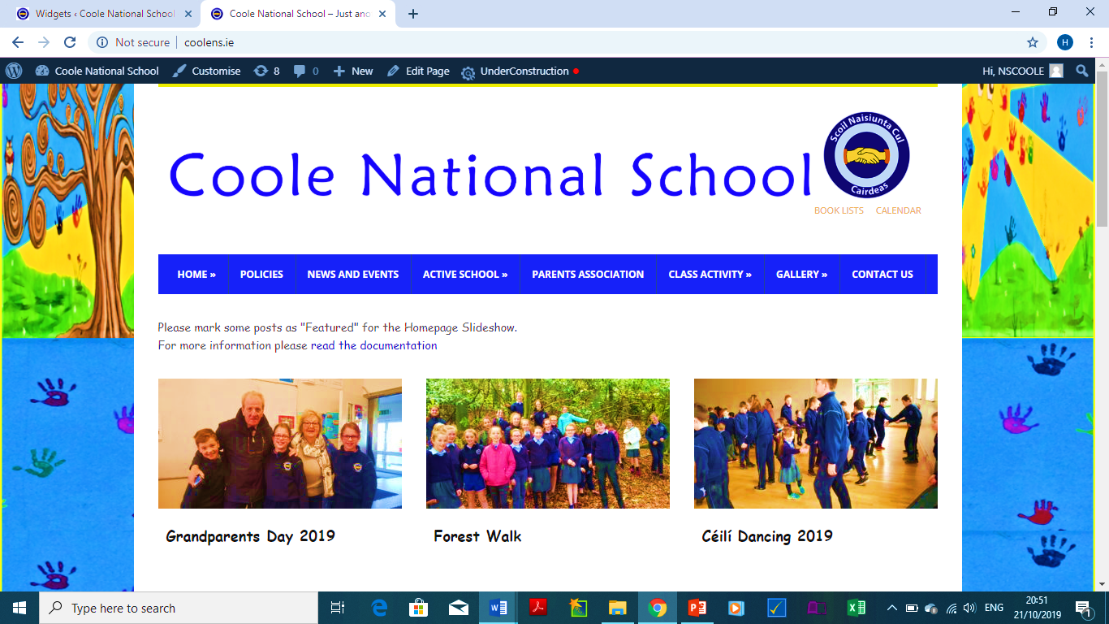 | Garadice,  Kilcock,  Co. Meath.  W23AXK8  Tel: (046)9557538  Email: cooleschool@gmail.com  Website: www.coolens.ie

Application for Admission School Year 2025/2026

Please note that this form is for application purposes only. The information provided will be used to allocate places in accordance with the School’s Admission Policy/Annual Admission Notice available to view at: www.coolens.ie. Please complete all sections of the form.
General Information on Child

1.Child’s First Name/s: | 2.Child’s Last Name:
3. Date of Birth: (Please attach Original Birth certificate) | 4.Child’s PPS No:
5. Gender: | 6. Home Address  Eircode:
7. Siblings in the school: Yes No

Name(s) of Sibling(s):

Sibling’s Class(es):
General Information on Parents/Guardians

1st Parent/Guardian Details |  | 2nd Parent/Guardian Details
Name: |  | Name:
Relationship to Child: |  | Relationship to Child:
Address (if different to above): |  | Address (if different to above):
Phone No (Mobile): |  | Phone No (Mobile):
Email Address: |  | Email Address:

Page 1 of 2
Declaration:
I, being the Parent/Guardian of the applicant, hereby confirm that the above information is true and accurate and I consent to its use as described.

Parent/Guardian’s Signature: | Date:

This Application MUST be accompanied by your child's ORIGINAL birth certificate.
The school will make a copy of the document(s) submitted and will return all of the original documents.

Data Privacy Statement

The information provided on this form will be used by Coole N.S. to apply the selection criteria for enrolment in Junior Infants, and to allocate school places in accordance with the School’s Admission Policy and the School’s Annual Admission Notice.

Where a pupil is admitted to the school, the information will be retained on the pupil’s file. On acceptance of an offer of admission, this information will be entered in the School Administration System (Aladdin Schools) and will be uploaded to the Primary Online Database. The Primary Online Database (POD) is a nationwide individualised database of primary school pupils, hosted by the Department of Education and Skills.

In the event of oversubscription, a waiting list of students whose applications for admission to Coole N.S. were unsuccessful due to the school being oversubscribed will be compiled, and will remain valid for the school year in which admission is being sought (See Section 12 – School Admission Policy).

Where a child’s name is placed on a waiting list, and the child is not admitted to the school, the information provided on this form will be retained for the duration of the school year and will be securely destroyed thereafter.

Section 66(6) of the Education (Admission to Schools) Act 2018 allows for the sharing of certain information between schools in order to facilitate the efficient admission of students. The information which may be provided to a patron or another Board of Management for this purpose may include all or any of the following:

- the date on which an application for admission was received by the school;
- the date on which an offer of admission was made by the school;
- the date on which an offer of admission was accepted by an applicant;
(iv) a student’s personal details including his or her name, address, date of birth and personal public service number (within the meaning of section 262 of the Social Welfare Consolidation Act 2005).

Office Use Only
*Date Application Received | D | D | M | M | Y | Y

Page 2 of 2

